
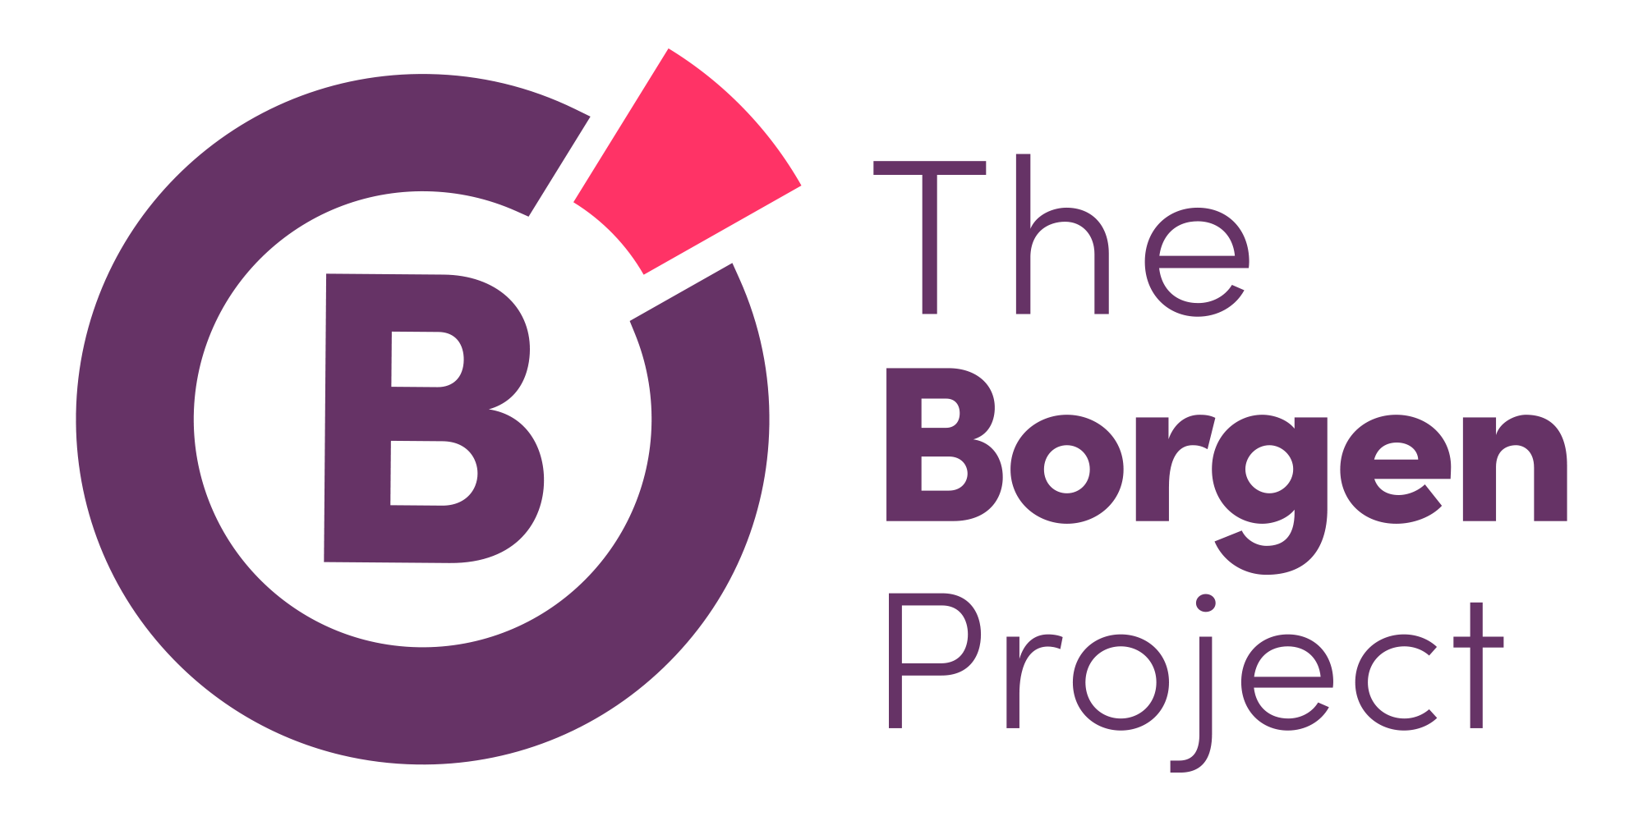
I am an Advocate

My Story
Share your story about why you joined The Borgen Project! There’s not any specific criteria your story has to meet, just whatever you want to share with others about why you are an advocate.
Please visit www.borgenproject.org to learn more and give a gift to help support poverty-reducing efforts.
I am an advocate because…
(put anything that matters to you! Try and think of something that will grab peoples attention and explain it more in depth below)
Name Position (Writer, Regional Director) Location
Delete this picture and put a picture of yourself here! Make it fun, it can be of you traveling or working with The Borgen Project.
Why I Care about the Borgen Project

